**Question-1**

Consider the virtual page reference string

1, 2, 3, 2, 4, 1, 3, 2, 4, 1

On a demand paged virtual memory system running on a computer system that has a main memory size of 3 pages frames which are initially empty. Let LRU, FIFO and OPTIMAL denote the number of page faults under the corresponding page replacements policy. Then

(A) OPTIMAL < LRU < FIFO

(B) OPTIMAL < FIFO < LRU

(C) OPTIMAL = LRU

(D) OPTIMAL = FIFO

**Answer : B**

the virtual page reference string is 1, 2, 3, 2, 4, 1, 3, 2, 4, 1 size of main memory pages frames is 3.

For FIFO: total no of page faults are 6 (depicted in red)

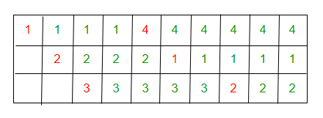

For optimal: total no of page faults are 5 (depicted in red)

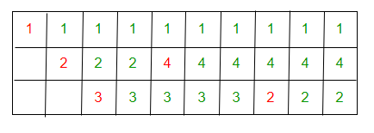

For LRU: total no of page faults are 9 (depicted in red)

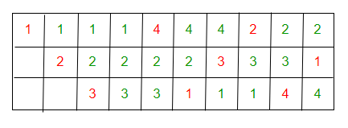

***The Optimal will be 5, FIFO 6 and LRU 9. so, OPTIMAL < FIFO < LRU option (B) is correct answer.***

**Question-2**

Suppose the time to service a page fault is on the average 10 milliseconds, while a memory access takes 1 microsecond. Then a 99.99% hit ratio results in average memory access time of

(a) 1.9999 milliseconds

(b) 1 millisecond

(c) 9.999 microseconds

(d) 1.9999 microseconds

**Answer: (d)**

**Explanation:**

***Average memory access time =***

***[(% of page miss)*(time to service a page fault) +***

***(% of page hit)*(memory access time)]/100***

So, average memory access time in microseconds is.

(99.99*1 + 0.01*10*1000)/100 = (99.99+100)/1000 = 199.99/1000 =1.9999 µs

**Question-3**

Let the page fault service time be 10ms in a computer with average memory access time being 20ns. If one page fault is generated for every 10^6 memory accesses, what is the effective access time for the memory?

(A) 21ns

(B) 30ns

(C) 23ns

(D) 35ns

**Answer (B)**

Let P be the page fault rate

Effective Memory Access Time = p * (page fault service time) +

                               (1 - p) * (Memory access time)

                             = ( 1/(10^6) )* 10 * (10^6) ns +

                               (1 - 1/(10^6)) * 20 ns

                             = 30 ns (approx)

**Question-4**

A system uses FIFO policy for page replacement. It has 4 page frames with no pages loaded to begin with. The system first accesses 100 distinct pages in some order and then accesses the same 100 pages but now in the reverse order. How many page faults will occur?

(A) 196

(B) 192

(C) 197

(D) 195

**Answer (A)**

**Explanation**

Access to 100 pages will cause 100 page faults. When these pages are accessed in reverse order, the first four accesses will node cause page fault. All other access to pages will cause page faults. So total number of page faults will be 100 + 96.

**Question--5**

Increasing the RAM of a computer typically improves performance because:

(a) Virtual memory increases

(b) Larger RAMs are faster

(c) Fewer page faults occur

(d) Fewer segmentation faults occur

**Answer (c)**